Assignment

A system would undergo the electrode reaction (A + ne → B) under a potential. Please make an analogy of the process of mass transfer of species A and indicate the concentration of A at different position from electrode surface to the distance by using the finite element analysis. In this case, only diffusion is under consideration. DA=10-9 m2/s

Boundary conditions:   
1. The initial concentration cA0 =1 mmol/L.

2. The concentration in the bulk (far away from the electrode surface) does not change with time.

3. The concentration at the surface of the electrode is zero all the time.

For example:

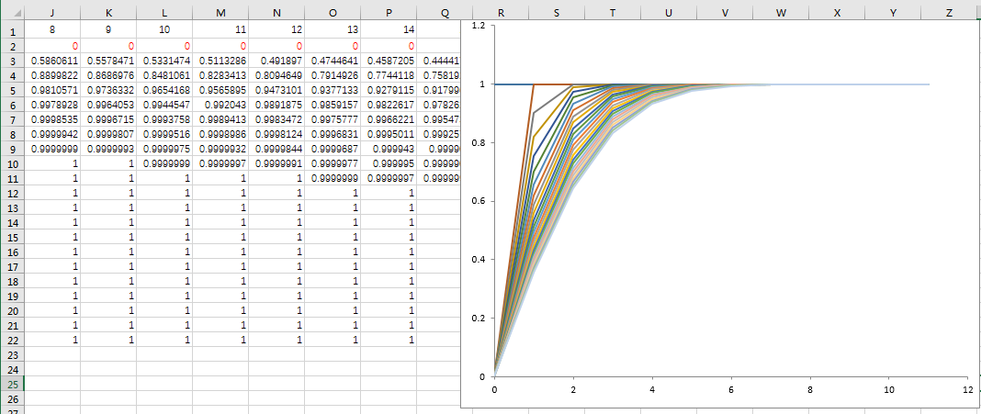

Extra one

How about the diffusion on cross section in HPLC? Only consider the linear direction of diffusion in the following picture. The initial concentration of C in the sample is c0, DC=2×10-5 cm2/s.

